Profit Maximization in Competitive Markets
Questions and Problems

Questions:
Use Figure 1 to answer questions 1-6
Figure 1
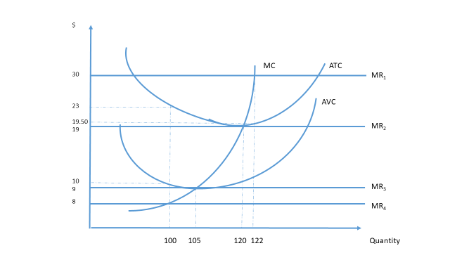
- In what price range will this firm make a positive profit?

- In what price range will this firm operate at a loss?

- In what price range will this firm shut down in the short run?

- If the market price is $8, what will this firm’s output and profit or loss be?

- If this firm is representative of all firms in the industry, what will the long-run price be?

- Assume the market price is $30.
  - What will the firm’s output be?
  - What will the firm’s revenues be?
  - What will the firm’s costs be?
  - What will the firm’s profit be?
  - In the long run, what is most likely to happen in this industry?
Use Figure 2 to answer questions 7 - 9
Figure 2
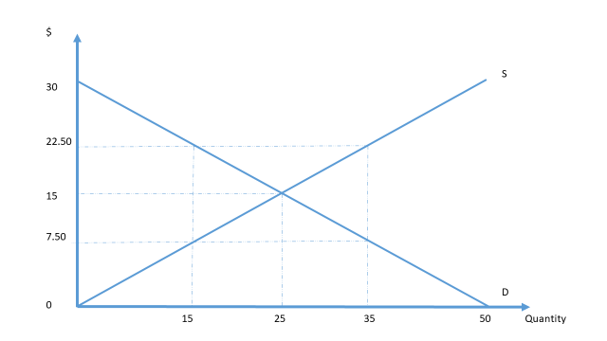
- In competitive equilibrium, what is
  - Consumer surplus?
  - Producer surplus?
  - Total economic surplus?

- Assume a price floor of $22.50 is imposed. What is
  - Output?
  - Consumer surplus?
  - Producer surplus?
  - Deadweight loss?

- If a price ceiling of $7.50 is imposed,
  - Will there be a surplus or a shortage?
  - Describe the transfer of surplus.
  - How much surplus is transferred?
  - Is society better off or worse off?

Answers:
- $19 - $30

- $9 - $19

- Below $9

- q = 0; losses equal fixed cost, $1300 [AFC is $23-$10; FC is $13 x 100]

- $19

  - 122
  - $3660
  - $2379
  - $1281
  - New firms will enter

  - $187.50
  - $187.50
  - $375

  - 15
  - $56.25
  - $281.25
  - $75

  - Shortage
  - Some of the equilibrium producer surplus is transferred to consumers.
  - $112.50
  - Worse off: there is a deadweight loss of $75

