Antitrust Policy and Government Regulation of Business
Questions and Problems

Questions:
Use the graph to answer questions 1-5.
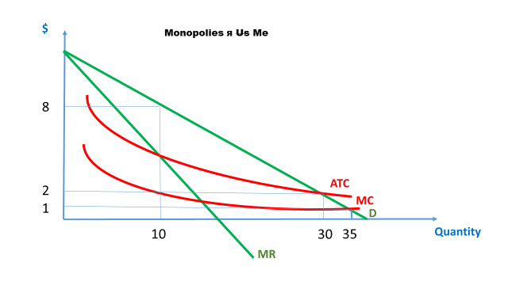
- If this firm is a private profit-maximizer, what output will it produce? What price will it charge?

- If the firm were regulated and instructed to set its price equal to marginal cost, what would its output and price be?

- What problem would arise in that case?

- If the firm were regulated and instructed to follow a zero-profit pricing mode, what would its output and price be?

- What is the change in consumer surplus moving to a zero-profit regulatory model from the private profit-maximizing model?

- Rank the following items according to the level of market concentration is most likely in each market, from least concentrated (most competitive) to most concentrated (least competitive).

  - Candycorn
  - An Aquaman costume
  - Paper bags with Halloween decorations for trick or treating
  - Projection systems to display witches and ghosts on the garage door

- Go to https://www.statista.com/statistics/271496/global-market-share-held-by-smartphone-vendors-since-4th-quarter-2009/ and compute the HHI for the global smartphone market. Assume that the “Other’ category consists of 12 firms, each with 2% of the market. How would the Department of Justice consider this industry? If Xiaomi, vivo, and Oppo merged, what would the new HHI value be?

- Go to https://www.counterpointresearch.com/us-market-smartphone-share/ and calculate the HHI for the U.S. market. This time, assume “Other” consists of two firms, each with 7% of the market.

Answers:

- Q=10; P=$8

- Q=35; P=$1

- The firm would make negative profits and eventually shut down.

- Q=30; P=$2

- $\frac{∆P×∆Q}{2}=\frac{6×20}{2}=60$

- c. Paper bags with Halloween decorations for trick or treating (low barriers to entry)
  - Candycorn (low barriers to entry, but some equipment needs and technical knowledge needed)
- Projection systems to display witches and ghosts on the garage door (higher barriers to entry due to capital costs)
- An Aquaman costume (copyrighted character)

- 1108. According to DoJ guidelines, this industry is fairly competitive.

If Xiaomi, Vivo, and Oppo merged, what would the new HHI value be? 1460

- 2588

